**Brooklyn torah gazette**

**For parshas vayechi 5782**

Volume 6, Issue 13 (Whole Number 268) 14 Teves 5782/ December 18, 2021

**Printed L’illuy nishmas Nechama bas R’ Noach, a”h**

For a free subscription, please forward your request to [***keren18@juno.com***](mailto:keren18@juno.com)

# Rav Avigdor Miller

# On Saying Tehillim



**QUESTION: Should a woman spend her spare time sewing and similar activities or saying Tehillim?**

**ANSWER:** I recommend a great deal of sewing and a little bit of Tehillim.  And I’ll explain why.

Tehillim is effective only when it’s accompanied by a certain concentration of the mind.  Just to mutter, to mumble the words is a very small accomplishment.

Now, when somebody wants to concentrate and think and reflect on the service of Hashem or in the noble ideals of Tehillim, very good! But how long can you keep it up?

And therefore, the rest of the time should be spent on something constructive and healthful.  And doing a creative thing like sewing, making dresses or clothing for the members of the family, it’s something that’s profitable – it costs a lot of money to buy things and some women are expert fashioners of garments – and it gives satisfaction to them too.  Of course, there are other forms of domestic arts that women could cultivate.



Now, I’m not saying women should not read seforim. If they’re capable of reading and profiting by seforim, why not?  But merely to say Tehillim all the time is impossible because even the most sincere and educated person tires of it after a while.

And therefore, as the question was posed, if there’s a choice between the two, I’d say more sewing and less Tehillim.

*Reprinted from the December 8, 2021 email of Toras Avigdor (Tape 553)*

**Parshas Vayechi:**

**Make Sure Brain is on**

**Before Putting Mouth in Gear**

**By Rabbi Bentzion Shafier**

**Founder of TheSmuz.com**

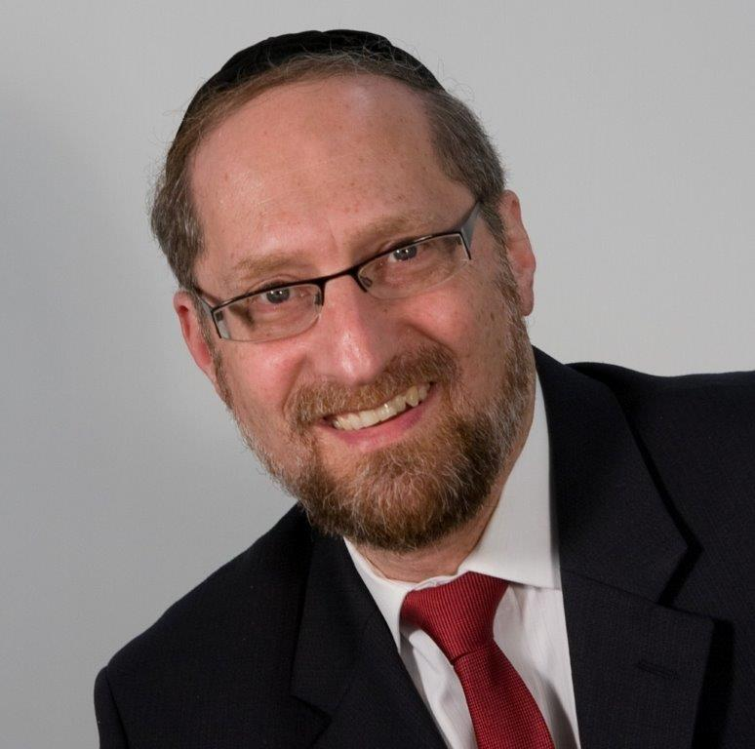

“*But as for me, when I traveled from Padam, Rochel died on me in the land of Canaan on the road, while there was still about a beras of land to go Ephras, and I buried her there on the road in Ephras, which is Bethlehem*.” – Bereishis 48:7

Yaakov Avinu spent the final seventeen years of his life in Mitzrayim. While there he lived in peace for the first time in many, many years and remained in that state for the rest of his life. Near the very end of his days, he called in his beloved son Yosef and made an impassioned request: “Please do not bury me in Mitzrayim.”

**Feeling His End Drawing Nearer**

After this event, when Yaakov felt his end drawing nearer, he again spoke to Yosef, saying, “On the road your mother Rochel died, and I buried her there.”

Rashi explains that these two conversations were connected. In this final meeting, Yaakov was expressing something that he had held inside for many years. He was telling Yosef, “I know that you have harbored a complaint in your heart against me. You feel that when your mother died, I didn’t treat her with due respect. I didn’t bury her in a city, or even in an inhabited place, but right there on the road where she died. You should know that I did this because HASHEM commanded me to. Many years from now, when Nevuzaradan will force the Jews into exile, they will pass along that road where she is interred. Rochel will cry out with bitter weeping, and her tears will save the Jewish people.”

**“If Not Now, When?”**

The Siftei Chachmim explains why Yaakov chose this particular moment in time to explain this to Yosef – “If not now, when?” He hadn’t told him up till then because he didn’t want to tell him about the suffering that was to occur. But he had to tell him now because it would be his last opportunity. He was about to leave this world.

This Rashi is difficult to understand. If HASHEM had told Yaakov to bury Rochel there, why didn’t Yaakov explain this to Yosef years ago? Why did he allow his beloved son to feel some sense of ill will against him for so long? Yosef was not a fragile youth who would fall apart if he heard bad news.

He was a mature, sophisticated talmid chacham. His role at the time was leader of all of Mitzrayim. He could have handled the knowledge that the Jewish nation would suffer. And Yaakov knew that eventually he was going to have to tell Yosef anyway. Why not just tell him right away and eliminate all of those bad feelings?

**The Sensitivity of a Tzaddik**

The answer to this question is that Yaakov Avinu was extraordinarily guarded in what he said. Every word was measured; every expression was weighed. And he had a policy: “I am not the one to cause suffering to others. If I tell Yosef why I buried his mother on the road, I will have to tell him that the Jewish people will be sent into exile.

That fact will cause him much suffering, and I won’t be a part of it. When he has to hear the bad news, I will tell him, but not a moment sooner. If this will cause him to have questions on my actions, if this will cause him to feel some element of resentment toward me, I am willing to pay that price, rather than cause him the pain of knowing what will occur.”

This Rashi illustrates a number of beautiful concepts. First, we see the extraordinary sensitivity that a tzaddik has in not causing another human being to suffer. Even though Yosef could “handle it,” and even though Yaakov would eventually have to tell him, he was willing to bear the burden of letting his son think of him as insensitive, rather than cause him pain. “I can’t be the one to cause another Jew to suffer.”

We also see a second point: an incredible example of discretion. Yaakov was extremely guarded in the words that came out of his mouth. Yaakov had been separated from his beloved son for twenty-two years. For those two decades, Yaakov was living in a state of unending mourning. When they finally met, Yosef was so filled with joy that the tears couldn’t be stopped. The love between the two was overflowing. And yet, there was something that stood between them. Yaakov knew that within the heart of his son was a sense of resentment, of ill will. In Yosef’s mind, his mother had been mistreated; her final honor had been compromised. And his own father was the man who dishonored her.

It wasn’t just at one moment that this was a barrier between them. For the next seventeen years, every time they spoke and every time they were together, there was a certain wedge keeping them apart. And yet Yaakov wouldn’t say a word. Even though these feelings were completely unfounded, he wouldn’t talk about it because that would cause a Jew to suffer, and he couldn’t be a part of that. This self-control is illustrative of the way that Yaakov lived every moment of his life.

**What this means to us**

When we study the Avos, we come to recognize that while we will never function on their level, we can gain insight and inspiration from them. And from their sensitivity we can become conscious of the power HASHEM gave us called speech. Our words can be the source of great comfort and support to others, or they can be callous, biting swords that cut away at the soul of those around us. With speech, we can build worlds . . . or destroy them.

*Reprinted from the website of Shmuz.com website.*

**Photo of an Aishes Chayil**

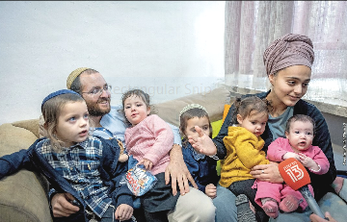

***Moriah Cohen with her family speaking to the press in her home in the Shimon Hazaddik neighborhood in Jerusalem after surviving a brutal stabbing last week on Dec. 8th by a teenage Arab girl who also lives in the same neighborhood.***

**Yosef’s Balancing Life in Exile and Yet Yearning**

**For Our Father’s House**

**From the Talks of the Lubavitcher Rebbe**

**Rabbi Menachem Mendel Schneerson, Zt”l**

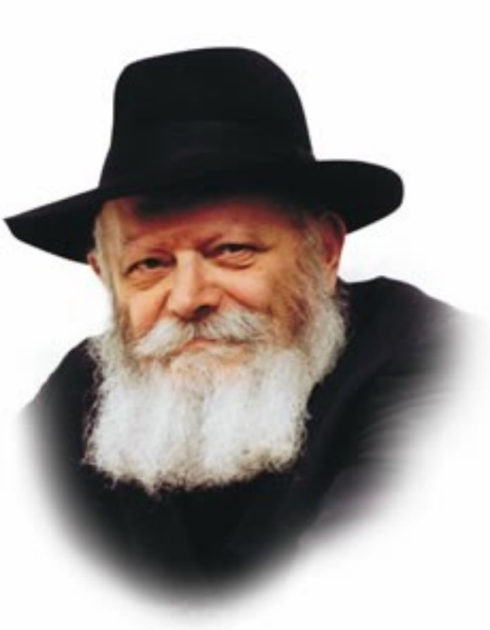

In the Torah portion of Vayechi, Yaakov blesses Yosef's two sons who were born in Egypt, Menashe and Efraim. These names were chosen by Yosef because they alluded to his circumstances in Egypt at the time when they were born.

Yosef named his firstborn Menashe, "For G-d has made me forget (nashani) all my troubles, and even my father's house." Far from home, Yosef was in danger of assimilating. Yet he remained connected to his people and to G-d. In choosing the name Menashe, Yosef indicated that he had, in fact, not forgotten his father.

Yosef named his second son Efraim, "For G-d has caused me to become fruitful (hifrani) in the land of my affliction." Not only have I not been influenced by the Egyptians, Yosef was saying, but precisely here, "in the land of my affliction," I established a family, became wealthy and made spiritual progress.

Menashe is symbolic of the bond Yosef shared with his father and the deep yearning he continued to feel for him.

**Yosef’s Success in a Vile and Depraved Land**

Efraim is symbolic of Yosef's success in Egypt, a land that was vile and depraved.

Our situation in exile is similar to that of Yosef in Egypt. In exile, we are far from our Father's house -- the Holy Temple -- and G-dliness is concealed. What can we do to overcome our predicament? How are we to conduct ourselves during our sojourn in "Egypt"?

The answer is to learn from Yosef, and emulate him.

On the one hand we are obligated to remember our "Father's house," to yearn for the Holy Temple and G-d's closeness. A Jew must never resign himself to the exile. Rather, we must always look forward to the Redemption, continue to observe Torah and mitzvot, just as Yosef refused to acclimate himself to Egypt and named his son Menashe.

**Where the Poverty of the Spirit Prevails**

On the other hand, we must always remember that it is precisely in exile, where poverty of the spirit prevails, that we must remain strong. Just as Yosef remained righteous and flourished in the land of his "affliction," so too must we spread Yiddishkeit and foster the belief in G-d precisely in a world that does not recognize His greatness.

When Yaakov blessed Yosef's sons, he placed his right hand on Efraim's (and not Menashe's) head, saying, "His younger brother shall be greater than he." For even though Menashe was the firstborn, and the beginning of our service must be the longing for our Father's house the main objective of our service in exile is expressed in the name Efraim: an increase in Torah and good deeds, thereby causing G-d's Name to be known in the world. By emphasizing this aspect, we will merit G-d's light to shine, even within the exile.

*Reprinted from Reprinted from the 5757/1996 Vayechi edition of L’Chaim Weekly, adapted from Likutei Sichot, volume 15*

**The Turn**

**By Liel Leibovitz**

***When I saw the left give up everything I believe in, I changed politically. You can, too.***



**Merchandise lies in a looted souvenir and electronics shop near New York’s Times Square after a night of protests and vandalism over the death of George Floyd, June 2, 2020 Photo by John Moore/Getty Images**

For many years—most of my politically cognizant life, in fact—I felt secure in my politics. Truth and justice, I believed, leaned leftward. If you were some version of a decent human being, you cared about those less fortunate than you, which meant that you supported a whole host of measures designed to even the playing field a little.

Sometimes, these measures had unintended consequences (see under: Stalin, Josef), but that wasn’t reason enough to despair of the long march to equality. Besides, there was hardly an alternative: On the other end of the political transom lurked despicable creeps, right-wing orcs who either cared for nothing but their own petty financial interests or, worse, pined for benighted isms that preached prejudice and hate.

We were on the right side of history. We were the people. We were the ones giving peace a chance. And, no matter the present, we were always the future.

This belief carried me through high school, and a brief stint in a socialist youth movement. It accelerated me in college, sending me anywhere from joint marches with Palestinians to a two-week hunger strike in Jerusalem trying (and failing) to lower tuition for underprivileged students. It pulled me to New York, to Columbia University, to more left-wing politics and activism and raging against Republicans whose agenda, especially in the 2000s, seemed like nothing more than greed and war.

**It Was the Animating**

**Spirit of Life Itself**

And it wasn’t just an ideology, some abstract set of convictions that were accessible only through cracking open dusty old books. It was the animating spirit of life itself: The dinner parties I attended on the Upper West Side required dismissive comments on President Bush just as much as they did a bit of wine to make the evening bright, and there was no faster or surer way to signal to a new acquaintance that you were a kindred spirit than praising the latest Times editorial. It wasn’t performative, exactly. At least, it felt real enough, the reverent rites of a good group of people protecting itself against the bad guys.

**A Mutual Embrace**

I embraced my people, and my people embraced me. They gave me everything I had always imagined I wanted: a Ph.D. from an Ivy League university; a professorship at NYU, complete with a roomy office overlooking Washington Square Park; book deals; columns in smart little publications; invitations to the sort of soirees where you could find yourself seated next to Salman Rushdie or Susan Sontag or any number of the men and women you grew up reading and admiring. The list goes on. Life was good. I was grateful.

**And Then Came the Turn**

And then came The Turn. If you’ve lived through it yourself, you know that The Turn doesn’t happen overnight, that it isn’t easily distilled into one dramatic breakdown moment, that it happens hazily and over time—first a twitch, then a few more, stretching into a gnawing discomfort and then, eventually, a sense of panic.

You may be among the increasing numbers of people going through The Turn right now. Having lived through the turmoil of the last half decade—through the years of MAGA and antifa and rampant identity politics and, most dramatically, the global turmoil caused by COVID-19—more and more of us feel absolutely and irreparably politically homeless.

**Instinctively Looking**

**To the Democratic Party**

Instinctively, we looked to the Democratic Party, the only home we and our parents and their parents before them had ever known or seriously considered. But what we saw there—and in the newspapers we used to read, and in the schools whose admission letters once made us so proud—was terrifying. However, we tried to explain what was happening on “the left,” it was hard to convince ourselves that it was right, or that it was something we still truly believed in. That is what The Turn is about.

You might be living through The Turn if you ever found yourself feeling like free speech should stay free even if it offended some group or individual but now

can’t admit it at dinner with friends because you are afraid of being thought a bigot. You are living through The Turn if you have questions about public health policies—including the effects of lockdowns and [school closures](https://www.tabletmag.com/sections/news/articles/school-closures-covid-alex-gutentag) on the poor and most vulnerable in our society—but can’t ask them out loud because you know you’ll be labeled an anti-vaxxer.

**Afraid that You will be Called**

**A White Supremacist**

You are living through The Turn if you think that burning down towns and looting stores isn’t the best way to promote social justice, but feel you can’t say so because you know you’ll be called a white supremacist. You are living through The Turn if you seethed watching a terrorist organization attack the world’s only Jewish state, but seethed silently because your colleagues were all on Twitter and Facebook sharing celebrity memes about ending Israeli apartheid while having little interest in American [kids dying on the streets](https://news.yahoo.com/11-children-among-26-people-195159910.html) because of failed policies. If you’ve felt yourself unable to speak your mind, if you have a queasy feeling that your friends might disown you if you shared yourmostintimately held concerns, if you are feeling a bit breathless and a bit hopeless and entirely unsure what on earth is going on, I am sorry to inform you that The Turn is upon you.

**The Warning from a Dear Friend**

The Turn hit me just a beat before it did you, so I know just how awful it feels. It’s been years now, but I still remember the time a dear friend and mentor took me to lunch and warned me, sternly and without any of the warmth you’d extend to someone you truly loved, to watch what I said about Israel. I still remember how confusing and painful it felt to know that my beliefs—beliefs, mind you, that, until very recently, were so obvious and banal and widely held on the left that they were hardly considered beliefs at all—now labeled me an outcast.

**The Turn Brings a Sort of Pain**

The Turn brings with it the sort of pain most of us don’t feel as adults; you’d have to go all the way back to junior high, maybe, to recall a stabbing sensation quite as deep and confounding as watching your friends all turn on you and decide that you’re not worthy of their affection any more. It’s the kind of primal rejection that is devastating precisely because it forces you to rethink everything, not only your convictions about the world but also your idea of yourself, your values, and your priorities.

We all want to be embraced. We all want the men and women we consider most swell to approve of us and confirm that we, too, are good and great. We all want the love and the laurels; The Turn takes both away.

**Then It’s OK to Be Right**

But, having been there before, I have one important thing to tell you: If the left is going to make it “right wing” to simply be decent, then it’s OK to be right.

Why? Because, after 225 long and fruitful years of this terminology, “right” and “left” are now empty categories, meaning little more than “the blue team” and “the green team” in your summer camp’s color war. You don’t get to be “against the rich” if the richest people in the country fund your party in order to preserve their government-sponsored monopolies.

**Do You Really Support**

**Free Speech?**

You are not “a supporter of free speech” if you oppose free speech for people who disagree with you. You are not “for the people” if you pit most of them against each other based on the color of their skin, or force them out of their jobs because of personal choices related to their bodies.

**Not Being Serious About**

**Economic Inequality**

You are not “serious about economic inequality” when you happily order from Amazon without caring much for the devastating impact your purchases have on the small businesses that increasingly are either subjugated by Jeff Bezos’ behemoth or crushed by it altogether.

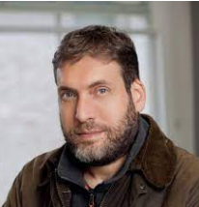

**Liel Leibovitz**

You are not “for science” if you refuse to consider hypotheses that don’t conform to your political convictions and then try to ban critical thought and inquiry from the internet. You are not an “anti-racist” if you label—and [sort!](https://nypost.com/2021/03/07/education-dept-curbs-decision-on-race-based-affinity-groups/)—people by race. You are not “against conformism” when you scare people out of voicing dissenting opinions.

**When One Joins the**

**Party of Wealthy Elites**

When “the left” becomes the party of wealthy elites and state security agencies who preach racial division, state censorship, contempt for ordinary citizens and for the U.S. Constitution, and telling people what to do and think at every turn, then that’s the side you are on, if you are “on the left”—those are the policies and beliefs you stand for and have to defend. It doesn’t matter what good people “on the left” believed and did

60 or 70 years ago. Those people are dead now, mostly. They don’t define “the left” any more than Abraham Lincoln defines the modern-day Republican Party or Jimi Hendrix defines Nickelback.

**“Is That Me?”**

So, look at the list of things supported by the left and ask yourself: Is that me? If the answer is yes, great. You’ve found a home. If the answer is no, don’t let yourself be defined by an empty word. Get out. And once you’re out, don’t let anyone else define you, either. Not being a left-wing racist or police state fan doesn’t make you a white supremacist or a Trump worshipper, either. Only small children, machines, and religious fanatics think in binaries.

Which isn’t to diminish the anger, hurt, and confusion you’re feeling just now. But it’s worth understanding that your story has a happy ending. The freedom you feel on the other side is so real it’s physical, like emerging from a long stretch underwater and taking that first deep breath in the cool afternoon air.

**One Reinvent Oneself**

None of it makes the lost friends or the lost career opportunities any less painful; but there’s no more potent source of renewable energy than liberty, and your capacity to reinvent—yourself, your group, your life—is greater than you realize.

So welcome to the right side, friend, and join us in laughing at all the idiotic name-calling that is applied, with increasing hysteria, to try and stop more and more normal Americans from joining our ranks. Fascists? Conspiracy theorists? Anti-science racist TERFs? Whatever. We have a better word to describe ourselves: free.

*Reprinted from the December 8, 2021 email of Tablet Magazine.*

**Shtadlanim: Zev Wolfson**

**By Jonathan Rosenblum**

[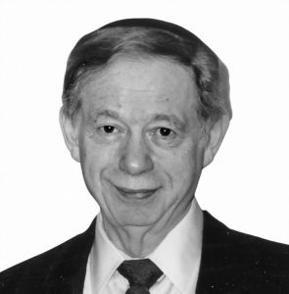](https://jewishaction.com/content/uploads/2021/11/Wolfson5.jpeg)

Zev Wolfson – courtesy of David Safier

Each person is unique, but most at least fall into certain broad categories and possess traits similar to others. Not so, Zev Wolfson (1928-2012). He was absolutely sui generis.

Between the early 1990s and Zev’s petirah in 2012, Keren Wolfson regularly gave away close to fifty million dollars a year in Israel, and sums in the tens of the millions elsewhere around the globe. And even those amounts paled in comparison to the monies he raised from various governments over the preceding three and a half decades.

If one word can capture him, it is relentless. Once he had identified his goal, he barely saw anything between him and that goal. On one of his first lobbying trips to Washington DC, he instructed his friend Amos Bunim to distract the secretary who had denied him access to a particular senator, while Zev vaulted over the office partition, at the risk of arrest, and into the startled senator’s office to plead his case.

It was Rav Aharon Kotler who first recognized that the chutzpah of the red-haired young businessman—who had arrived in America as a seventeen-year-old, penniless immigrant, after spending the war years in Kazakhstan—could be utilized on behalf of Klal Yisrael.

Rav Aharon once sent him to Israel with a letter of introduction to the leaders of Chinuch Atzmai, which stated simply, “He gets things done no one else can.”

Then Israeli Finance Minister Levi Eshkol, on a trip to America to plead the fledgling state’s case for American aid, was shocked to be asked repeated questions about Chinuch Atzmai by the senators on the Foreign Relations Committee, though none could come close to pronouncing the organization’s name. But Eshkol got the point: More favorable treatment of Chinuch Atzmai by the Israeli government would bolster Israel’s case for American aid.

Eshkol may have left DC muttering on that occasion, but he and subsequent finance ministers had reason to be profoundly grateful to Wolfson.

**[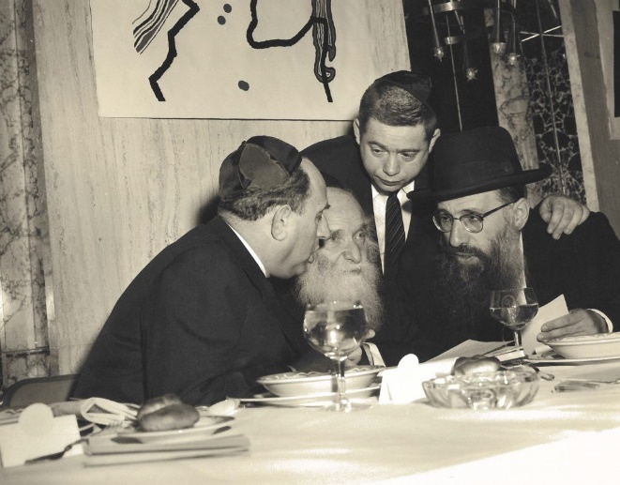](https://jewishaction.com/content/uploads/2021/11/Wolfson2-scaled.jpg)**

**From left: Stephen Klein, Rabbi Aharon Kotler, Zev Wolfson (standing), and Rabbi Menachem Porush at the Chinuch Atzmai dinner, circa 1956. Courtesy of BMG Archives**

A former senior Treasury official once told me that when the economic history of Israel is written, Zev Wolfson will be one of the three seminal figures, along with Prime Minister David Ben-Gurion and long-time Finance Minister Pinchas Sapir. Again and again, Wolfson was able to use his connections in the Senate Foreign Affairs Committee, chiefly with Senator Daniel Inouye (D-Hawaii), to save Israel billions of dollars.

In 1985, at a time of hyperinflation in Israel, Wolfson shepherded through Congress an appropriations bill that permitted Israel to refinance existing loans by prepaying the existing loans and taking new ones, with US loan guarantees, at much lower interest rates, thereby saving Israel hundreds of millions of dollars.

In 1989, when Israel was desperate for funds to finance the absorption of hundreds of thousands of refugees from the Former Soviet Union, Wolfson played a major role in securing tens of billions of dollars in US government loan guarantees.

During the 1991 Gulf War, Wolfson invited Senator Inouye out on his boat. Israel was being pounded by Iraqi Scuds, and Wolfson wondered aloud whether there wasn’t anything in the American arsenal that could protect against them.

Inouye told him about the Patriot missile and speculated that Israel must not have asked for them. Wolfson immediately called his friend, Defense Minister Yitzchak Rabin, to relay the message. The next day’s New York Times reported that the Patriots were on their way.

For decades, there was a “Seif Wolfson” in the Israeli budget, in gratitude for Wolfson’s immense services to Israel, all rendered behind the scenes and without any publicity. Monies from that budget went to finance religious schools in France (for which Wolfson had secured the land from President Jacques Chirac), kiruv activities in Russia, and a network of residential religious dormitory schools in Israel for children from disadvantaged backgrounds. All based on Wolfson’s early recognition that governments have much more money to give out than individuals.

When new transparency rules rendered Wolfson’s means of directing funds to religious institutions no longer viable, he simply began donating himself on a scale unprecedented in Jewish history.

Asked by a senior official at Morgan Stanley how he had made his money, he answered without hesitation, “God gave it to me.” And based on that recognition, he and his descendants after him gave prodigiously.

Jonathan Rosenblum is a journalist who writes for several Orthodox media publications, and has a weekly column in Mishpacha.

*Reprinted from the current Winter 2021 edition of the Orthodox Union’s Jewish Action magazine.*

**Thoughts that Count**

This week's Torah portion speaks of Yaakov's death, yet it begins with "and Yaakov lived." The Hebrew word for "and he lived," vayechi, has the numerical value of 34. Yaakov lived for 147 years. Of those years, the ones he enjoyed most were the 17 years that Yosef lived at home before his brothers sold him, and the 17 years after Yaakov was reunited with Yosef until his passing, totalling 34 years. *(Ba'al Haturim)*

*He blessed Yosef saying, "The angel who redeemed me from all evil should bless the lads [Menashe and Ephraim]"* (Gen. 48: 15-16)

Yaakov began by blessing Yosef, but ended up blessing Yosef's sons. Yaakov's blessing to Yosef was that his children, Menashe and Ephraim, would be righteous and G-d-fearing Jews whom Yosef could be proud of. This is the greatest blessing for a parent. *(Zohar)*

*Gather together (Gen. 49:1). Gather together* (Gen.49:2).

Yaakov told his sons to gather together twice. This actually hints to the two times that all of the Jews would be gathered together from exile. The first time was when the Jews were brought back to Israel from the Babylonian Exile, and the second time will be when we are all brought back to Israel with the coming of Moshiach. *(Torah Shleima)*

*Reprinted from Reprinted from the 5757/1996 Vayechi edition of L’Chaim Weekly, Reprinted from Vedibarta Bam by Rabbi Moshe Bogomilsky*